NOC x CTC Skills Accelerator Program 2026 – CHALLENGE 1
Stem Stream | Data Analysis
Proposed by | Vidya in consultation with APS team at BODC
Background context | Analysing Real Ocean Temperature data

Background Context:
Ocean temperature varies at different depths of the Ocean. Sunlight warms the water but as we travel deeper into the ocean, the temperature is much lower. Scientists study these temperature differences to understand ocean currents and weather. They provide a lot of insight about marine life too.
Rather than using a small sample dataset, scientists use ERDDAP, an online data server which lets them subset, view and graph huge ocean datasets directly in the browser. Because ERDDAP only sends back the exact data you ask for - already labelled and in a consistent format - it saves a lot of time downloading, cleaning large files and results in less error. You can learn more about ERDDAP in the ERDDAP section below.
Before scientists can use a dataset, they also need metadata, which is information that describes the data and explains where, when, and how it was collected. Good metadata helps researchers understand and trust the data they are using. You can learn more about metadata in the Metadata section below.

Challenge Information:
- Look at the deployment catalogue and note down all the metadata about the deployment (who deployed, instruments fitted, what the instrument measured, etc)
ere is an example of metadata for deployment 507
The Metadata page
  - As you investigate, write down all the information that is missing or hard to find. This will be used for your explanation on the importance of good metadata.
  - For example:
Navigate to the deployment catalogue
Select a Campaign, for example “BIO-Carbon”
Navigate to the metadata page for the platform name “Cabot (unit_345)”
    - What instruments are on this deployment?
    - Describe the parameter TEMP_DOXY
    - Who is the manufacturer of the Oxygen optode 4831 119
    - What is the model controlled vocabulary for the WETLABS FLBBCD-SLC 3325
- Use ERDDAP’s built in graphing tool and plot temperature vs depth and temperature vs time. Try to subset your data for a specific date range so you can read the graphs
- Look for patterns in your graphs.
For example:
  - Navigate to https://linkedsystems.uk/erddap/tabledap/Bowmore_712_R.graph
  - Navigate to AtlantiS sg605 (deployment 712) real-time seaglider data.
  - Use the graph to find the maximum depth on this deployment?
  - Use the graph to find the temperature range between the 3rd and 5th March
Here is the link to an example to view graphs generated by ERDDAP
  - Do you notice any thermocline (boundary between warmer and colder temperature)?
  - How is the temperature changing? Is it random over weeks or over days?
  - How do you think this affects animals that live at that depth?
- If you have attended the Python session
  - Export a small subset of your chosen data to a csv file from ERDDAP. Refer to the ERDDAP section below
  - Use python packages such as matplotlib to plot graphs such as temperature vs depth, temperature vs time or two depths compared side by side for the same time axis.
- Using LLMs
  - If you have completed the challenge by exploring the datasets using Python, you could explore using LLMs to extract details of the datasets and compare with your results.

Poster to include
- Mission fact file – deployment name, dates, campaign details, Principal Investigator
- Missing or hard to find metadata which is important
- A map of where the glider travelled
- At least 1 graph of real data with some simple explanation
- A summary of what the mission was about. For example, what was the scientist trying to find or what was discovered.
- References to sources

Resource Materials: Focus | Link
BODC Deployment catalogue | Deployment Catalogue
BODC’s ERDDAP server | Linkedsystems.uk/erddap
How ERDDAP works
Example of ERDDAP graph | ERDDAP - AtlantiS sg605 (deployment 712) real-time seaglider data - Make A Graph
Glider information | EGC European Glider Community - European Glider Community
Webinars and videos from Glider community | WEBINARS - European Glider Community

Starter code
Refer the jupyter notebook for a starter code to read real BODC glider data and plot the various graphs . Use it by swapping the URL of the dataset that you have chosen.

NOC x CTC Skills Accelerator Program 2026 – CHALLENGE 2
Stem Stream | Environment Policy, Oceanography
Proposed by | Vidya Krishnan
Background context | Storm Surges

Background Context:
Sea level does not just rise and fall due to tides. Weather systems can bring low pressure and strong winds to an area, which can then “suck up” or push extra water towards the coast. This is called storm surge. This extra water is known as the ‘residual’. The residuals are the differences between the sea level that a storm produced and the tidal prediction. The additional water above the normal tide can cause coastal flooding. This can be particularly dangerous during periods of exceptionally high spring tides.
The NOC develops a UK wide surge model, which is driven by the tides and the weather, and is used operationally (by the UK Met Office) to predict how much a storm will raise sea level, in addition to the tides, at the various ports around Britain. The NTSLF (National Tidal and Sea Level Facility) publishes an online archive of operational forecasts comparing these predictions against the residuals actually observed at the tide gauges.

Challenge Information:
- Identify some dates when there were known storms in UK.
For example, Met Office library for historical weather: | https://www.metoffice.gov.uk/research/library-and-archive/publications/historical-facts/historical-weather
Flood forecasting | https://www.gov.uk/government/organisations/flood-forecasting-centre
For UK storms 2025/26 | https://weather.metoffice.gov.uk/warnings-and-advice/uk-storm-centre/uk-storm-season-202526
storms before 2013 only: the list the biggest historical surges at each tide gauge, by region. | NTSLF skew surge history pages
For UK storms 2023/24 | https://weather.metoffice.gov.uk/warnings-and-advice/uk-storm-centre/uk-storm-season-2023-24
- Next read the details of the storm and find the impacts and the areas in UK that it affected.
  - Read about the storm’s impact and which parts of UK it affected
  - For example :For storm ciaran - it shows where the strongest winds were expected (southern coasts of England)
- Using what you have read , list 3 or 4 ports in the affected areas. Also pick one port well away from the storm to see comparison
- Go to the NTSLF surge model archive. It holds historical tide gauge readings alongside the computer-generated storm surge model. Storms before 2020 are in the 2004-2019 archive.
- From the NTSLF surge model archive choose the UK port and investigate the data for the month when an identified storm occurred:
  - Visit the NTSLF surge model archive (https://ntslf.org/) which contains the historical tide gauge readings and computer generated storm surge models.
  - Choose the UK port that you plan to investigate.
  - Investigate the particular date of the particular month when the storm occurred ( e.g. Storm Babet or Storm Ciaran in late 2023).
- Read the surge plot and understand what the model predicted, the data collected by the gauges and the time closest to HIGH water.
- Investigate the timing of the surge relative to the high tide (before, During, or after) and the flood risk it posed.
- Make a poster explaining what a storm surge is and why the models need to be accurate and how it keeps people safe.
- Using Large Language Models (AI)
  - If you have completed the challenge you could explore using Large Language Models to extract details compare with the information you had gathered and analysed.

Poster to include
- Port and month you investigated with details of surge/residual plot
- Explanation of tide vs surge residual
- Evidence of the storm event that you chose
- Explanations of why these predictions are important
- References to sources

Resources
animations of the model forecast | https://ntslf.org/storm-surges/surge-model
Current flood warning by Gov | https://check-for-flooding.service.gov.uk/alerts-and-warnings
Surge model archive (choose port /year/month) | https://ntslf.org/storm-surges/surge-model/monthly-surge-plots?port=Liverpool&year=2026&mnth=6
What is storm surge | https://ntslf.org/storm-surges/about-storm-surges
Latest surge forecasts | https://ntslf.org/storm-surges/surge-model/surge-forecast
UK tide gauge network | https://ntslf.org/tides/uk-network

NOC x CTC Skills Accelerator Program 2026 – CHALLENGE 3
Stem Stream | Oceanography
Proposed by | Magda Juarez and Tobias Ferreira
Background context | Evolution of Sea Ice Age in the Arctic Ocean
Background Context:
Arctic sea ice is home of some ice-dependant animals like seals, walruses, polar bears and some birds, which provides them a place for hunting, resting and breeding. Poor ice conditions affect animal livelihoods and abilities to reproduce. Also, thriving small communities living on the coast rely on sea ice for travel and hunting and to protect coastline from strong windstorms.
Arctic sea ice moderates global heat exchange between the ocean an atmosphere, sustains polar wildlife and acts as a sensitive indicator of climate change. Its bright white surface reflects most incoming sunlight back into space, a property known as high albedo, which helps stabilize the global climate. So, monitoring Arctic sea ice is critical because changes in the polar ice cap directly drive global weather patterns, ocean circulation and marine ecosystems.
The ‘Breaking the ice’ portal, developed by NOC, lets you track 40 years of shrinking Arctic sea ice in few minutes. Watch how sea ice age has changed from 1984 to 2024 through monthly views (‘Month’ option), year-by-year updates (‘Year’ option), or 40-year monthly average (‘Average (month)’ option). Sea ice age metadata is available at the bottom of the portal, providing context and details about the dataset.
To understand a dataset properly, scientists also use metadata, which is information that describes the data and explains how it was collected and processed. The sea ice metadata is available at the bottom of the portal and provides important background information about the dataset. You can learn more about metadata in the Metadata section below.

There is also a CSV file containing monthly statistics derived from the sea-ice age data. These statistics include the monthly mean, standard deviation of sea ice age, broken down by month and year, and the area covered by sea ice in different age categories: 0-1 years, 1-2 years, 2-3 years, 3-4 years, and more than 4 years old. You can use this information to support your analysis and provide more detailed and quantitative answers. The file is available here (age_of_sea_ice_statistics.csv), and here you can find the metadata that explain each column of the file (metadata.txt).

Challenge
Visit ‘Breaking the ice’ portal and:
- Identify metadata for the portal’s sea ice age dataset and explain what it reveals about the data.
- Identify the scientific methods used to gather sea ice age data.
- Identify which years have the least sea ice in the Arctic Ocean.
- Identify which month has the most sea ice on average.
- If you have attended the Python session
  - Take a look at the “age_of_sea_ice_statistics.csv” file
  - Use Python packages such as pandas and matplotlib to explore and visualise the data.
  - Try creating plots that show how the mean sea-ice age changes over time, or compare how the area covered by different sea-ice age categories changes through time.
- Make a poster to compare the sea ice of September 1984 and September 2024 explaining how the albedo has changed and how this could impact to Arctic environment, wildlife and community.

Poster to include

- Brief introduction to sea ice age dataset including its metadata.
- Methods used to gather sea ice age data.
- Find the years that had the least sea ice in the Arctic Ocean.
- Find the month which has the most sea ice on average.
- Findings: Briefly explain the difference in albedo between sea ice from September 1984 and September 2024 and the impact to Arctic environment, wildlife and community. Include a screenshot for each case.
- Conclusions or key takeaways of your findings.
- References to sources

Resources
Breaking the Ice portal | https://sap.breakingtheice.noc.ac.uk/
EASE-Grid Sea Ice Age, Version 4 | https://nsidc.org/data/nsidc-0611/versions/4#anchor-data-access-tools
Sea Ice – Why it Matters | https://nsidc.org/learn/parts-cryosphere/sea-ice/why-sea-ice-matters

What is Metadata
Metadata is information that describes a dataset. It helps other people understand what the data contains, where it was collected, who collected it, and how it was collected.
The British Oceanographic Data Centre (BODC) requires detailed metadata whenever data is submitted. Good metadata makes it easier for other researchers to find, understand, store, and reuse the data in the future.
When a dataset is submitted for archiving, BODC expects information about the data, the methods used to collect it, the people and organisations involved, and any processing or quality checks that have been carried out.

What information should the metadata include?
Metadata should explain:
- What equipment and methods were used to collect the data (for example, sensors, instruments, or laboratory techniques).
- How the data is organised and identified, such as station numbers or survey locations.
- Who collected the data, including the researchers and organisations involved.
- What has been done to the data, such as cleaning, processing, calibration, or calculations used to create new measurements.
- Any limitations or issues that users should be aware of, including data quality concerns or problems encountered during collection.

Metadata templates
When submitting a dataset, specific metadata templates must be completed. These templates include sections for:
- General information about the dataset, such as its purpose and scope.
- Details about data files, including measurements collected from sensors and samples.
- Information about numerical models and any related model-generated data.
Example of a template provided by BODC
￼
Here is the link to download other metadata templates of BODC - metadata Template￼

See a real example
You can view an example of metadata that accompanied a dataset collected by two Slocum gliders in the Southern Ocean by clicking here.

Learn more
More guidance on creating high-quality metadata can be found in the MEDIN Data Guidelines and through Ocean Best Practices, which provide internationally recognised standards for documenting and sharing marine data.

ERDDAP

How to view, PLOT and download data
Scientists collect enormous amounts of ocean data every day from instruments such as gliders, buoys, research ships, satellites, and ocean models. Finding the right data and downloading it in a usable format can be challenging. ERDDAP is a tool that makes this much easier.
ERDDAP is a free, open-source data server originally developed by the National Oceanic and Atmospheric Administration (NOAA). It provides a simple and consistent way to search, view, and download scientific datasets from many different sources.
With ERDDAP, users can:
- Search for datasets from around the world.
- Preview data before downloading it.
- Choose only the variables they need.
- Download data in different formats, including CSV, which can be easily analysed using Python.
- Create quick graphs and maps directly in a web browser.
One of ERDDAP's most useful features is that it can connect to datasets stored by other organisations. This is known as federated access. Instead of creating multiple copies of the same dataset, organisations can share data directly from the original source. This means everyone is accessing the most up-to-date version of the data, creating a single source of truth.

BODC's ERDDAP
The British Oceanographic Data Centre (BODC) hosts an ERDDAP server that provides access to a wide range of marine datasets. You can access it here:
🔗 https://linkedsystems.uk/erddap/index.html

Why use ERDDAP?
- Easy to search for datasets.
- View data before downloading
- Select only the data you need.
- Download in multiple formats such as CSV, JSON and NetCDF.
- Access data from different organisations through a single interface.
- Widely used by oceanographers and environmental scientists

How to use ERDDAP to inspect

Step 1: Open the ERDDAP Dataset List
Go to the BODC ERDDAP dataset catalogue:
🔗ERDDAP - List of All Datasets
This page contains hundreds of ocean datasets collected from gliders, ships, moorings, and other observing platforms.
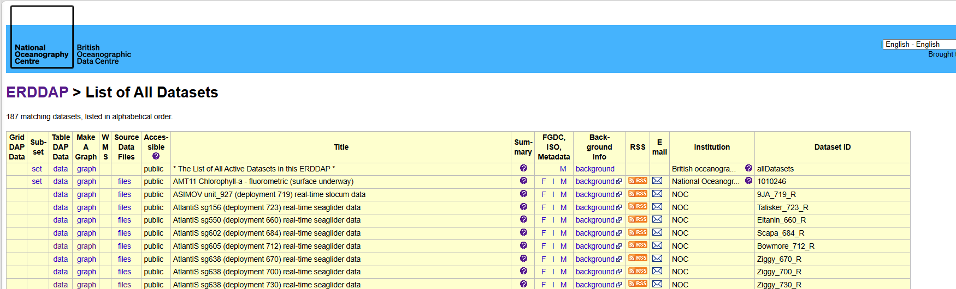

Step 2: Find the Dataset
Scroll through the list or use your browser's search function (Ctrl + F) and look for any dataset
Example: AtlantiS sg638 (deployment 730) real-time seaglider data
When you find the dataset, click the data link in the TableDAP Data column.
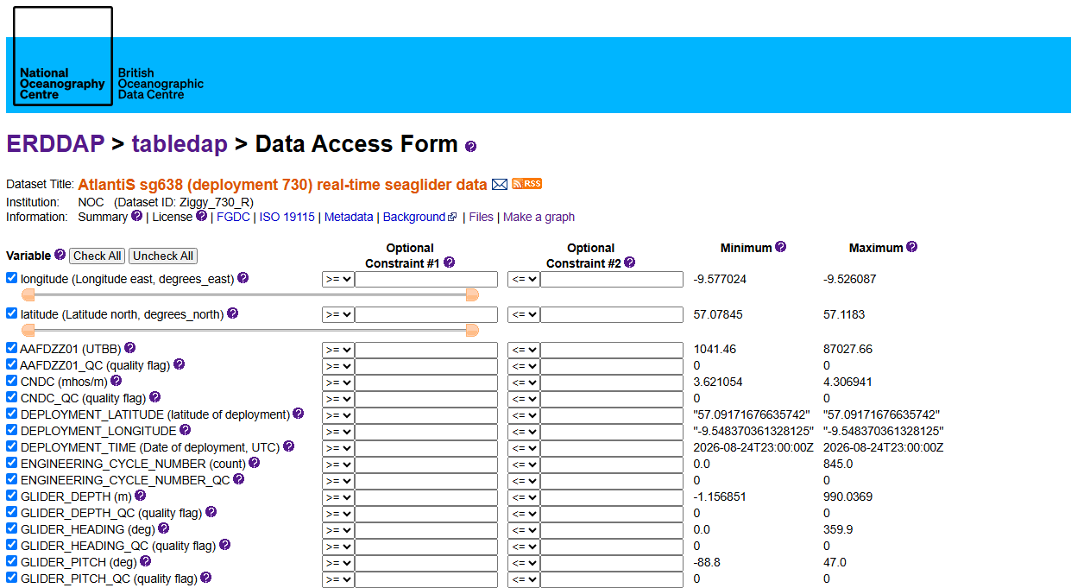

Step 3: Explore the Data Access Form
The Data Access Form will open.
This page allows you to:
- View all available variables in the dataset
- Select the variables you want to download
- Apply filters to reduce the amount of data returned
- Choose an output file format
Examples of variables available include:
- Longitude
- Latitude
- Depth
- Temperature
- Salinity
- Time
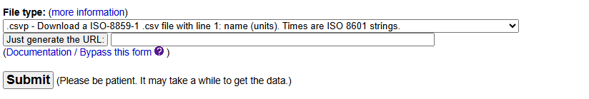

Step 6: Inspect the CSV File downloaded
Open the downloaded CSV file using:
- Microsoft Excel
- VS Code
You will see rows and columns of data similar to the example below.
time | latitude | longitude | temperature
2026-08-24T23:00:00Z | 57.09 | -9.54 | 11.8
2026-08-24T23:15:00Z | 57.10 | -9.53 | 11.7
2026-08-24T23:30:00Z | 57.11 | -9.52 | 11.6
Each row represents a measurement collected by the seaglider.

Step 7: Preview the Data as a Graph
Instead of downloading immediately, ERDDAP can also create graphs directly in your browser.
Click graph from the dataset page and choose variables to plot.
For example:
- Temperature vs Time
- Depth vs Time
- Salinity vs Depth
This allows you to quickly explore the data before downloading it.
Below is an example
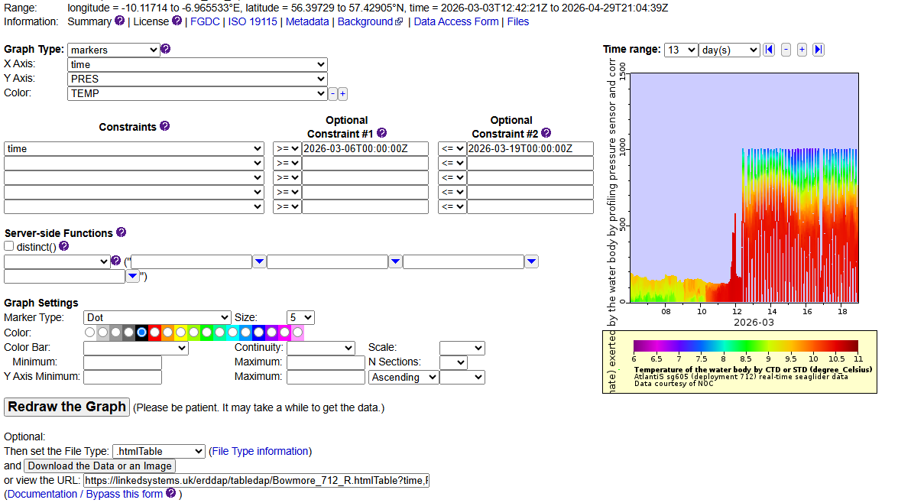

Step 8: Save Your Results
ERDDAP allows you to:
- Download the graph as an image
- Download the underlying data
- Return to the dataset and select different variables
Scientists often use this feature to quickly check whether a dataset contains useful information before carrying out a more detailed analysis.

Step 9: Analyse the Data Using Python
Once you have downloaded the CSV file, you can load it into Python and start exploring the data.
For example, you could:
- Plot temperature changes over time
- Compare temperature and depth
- Calculate averages and maximum values
- Look for patterns and trends in the ocean data
This is how many marine scientists begin turning raw observations into useful scientific insights.

JUPYTER notebook ---for exploring the data
Link to Jupyter notebook exploring a dataset
￼

Challenge 2 : for storm Ciaran

Picking the STORM and DATE
Storm Chosen | Storm CIARAN
Date named | 29 October 2023
Date of Impact | 1 –2 N0vember
source | https://weather.metoffice.gov.uk/warnings-and-advice/uk-storm-centre/uk-storm-season-2023-24

Impact of Storm
Regions affected | South West England & Devon" under Amber Warning
Ports in Region Devon in NTSLF map | Devon
Tidal Guages at | Devonport (Plymouth)
source | https://www.metoffice.gov.uk/about-us/news-and-media/media-centre/weather-and-climate-news/2023/storm-ciaran-latest  https://www.metoffice.gov.uk/about-us/news-and-media/media-centre/weather-and-climate-news/2023/storm-ciaran-named  https://www.gov.uk/government/news/prepare-for-storm-ciaran

Prediction models analysis
Surge model | https://ntslf.org/storm-surges/surge-model/monthly-surge-plots?port=Plymouth&year=2023&mnth=11
Model predictions | The computer model predicted a sharp rise in atmospheric surge starting on November 1, reaching a forecasted peak of around 0.8 metres in the early hours of November 2.
Guage data | The tide gauge collected real-time observation data that closely tracked the model's trajectory, showing an observed peak that slightly exceeded the model, reaching nearly 1.0 metre above predicted normal astronomical tide on November 2
Observations | Timings:  The peak surge occurred before and during the approach to High Water on November 2.  Flood Risk:  Because the maximum atmospheric elevation(non tidal residual)from the NTSLF plot (~0.8 to 1.0 m) coincided directly with the flood tide building up to High Water, total sea levels rose significantly. This directly helps to determine the floodrisks and overtoppings  Statistics:  Correlation Coefficient: The plot lists a Hourly Data Correlation Coefficient of 0.934 (and 0.939 for High Water data).  Thus the computer model accurately tracked the timing and amplitude of the real-world surge measured at the tide guage.

